
Koneru Lakshmaiah Education Foundation
(Deemed to be University estd. u/s. 3 of the UGC Act, 1956)
Off-Campus: Bachupally-Gandimaisamma Road, Bowrampet, Hyderabad, Telangana - 500 043. Phone No: 7815926816, www.klh.edu.in

STUDENT CASE STUDY EXECUTION REPORT
Department | FED
Sub'ect | DSA-2
Academic Year | 1-III Semester | 2025-26
Facult Name | Mohd.Razia
Student Name | U.Shiva Reddy
Roll Number | 2520090172
Branch | CSIT
Course Outcome | CO-4
Case Study Topic: Optimal Route Selection for Tournament Logistics using Dijkstra's Algorithm
Work Done Summary:
In a national sports tournament, teams travel between multiple stadiums. The SportsAnalytics system calculates the shortest route between venues to reduce travel time and transportation costs. Dijkstra's Algorithm is used to find the shortest path between stadiums.
Implementation Details:
1) Represent stadiums as graph vertices.
2) Represent road distances as weighted edges.
3) Apply Dijkstra's Algorithm.
4) Calculate shortest distance from source stadium.
5) Display optimal routes and distances.
Result: Screenshots / Output
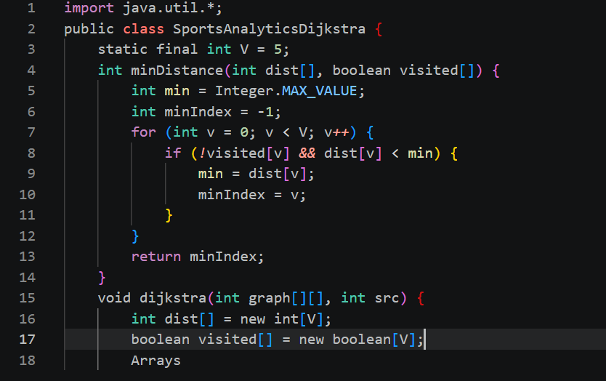
GitHub Link: https://github.com/Shiva77661/SportsAnalytics-Athlete-Performance-Tournament-Management-System/commit/f141e1d9daff53d2bfed481b847fdc2a6c7732b7
Student Signature Faculty Signature

